**Lab 08 Task**



**Name Hammad Arshad**

**Roll no SU92-BSAIM-F23-030**

**Section BSAI-4A**

**Subject PAI (LAB)**

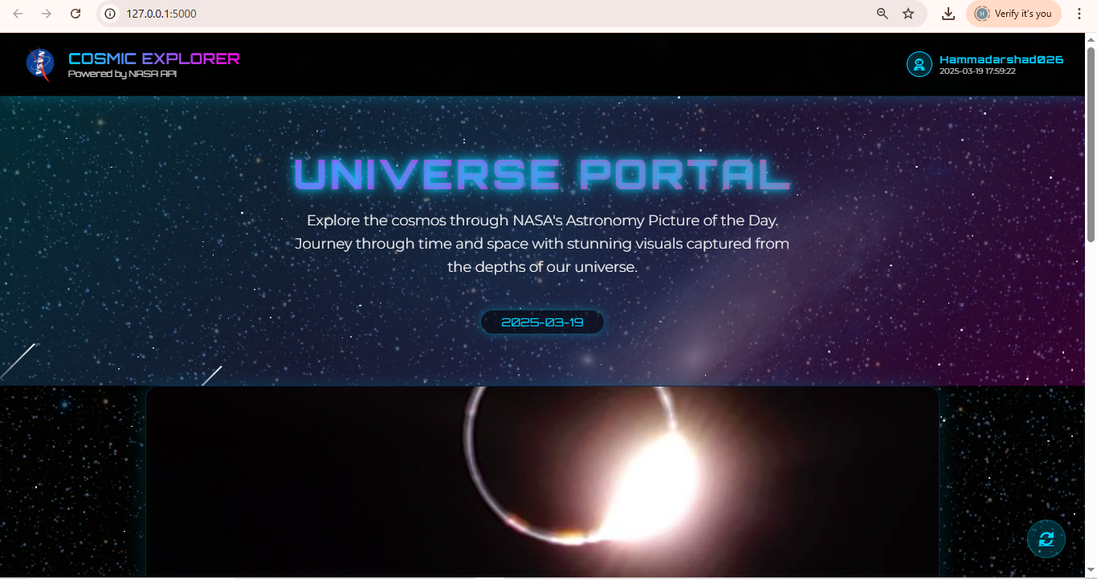

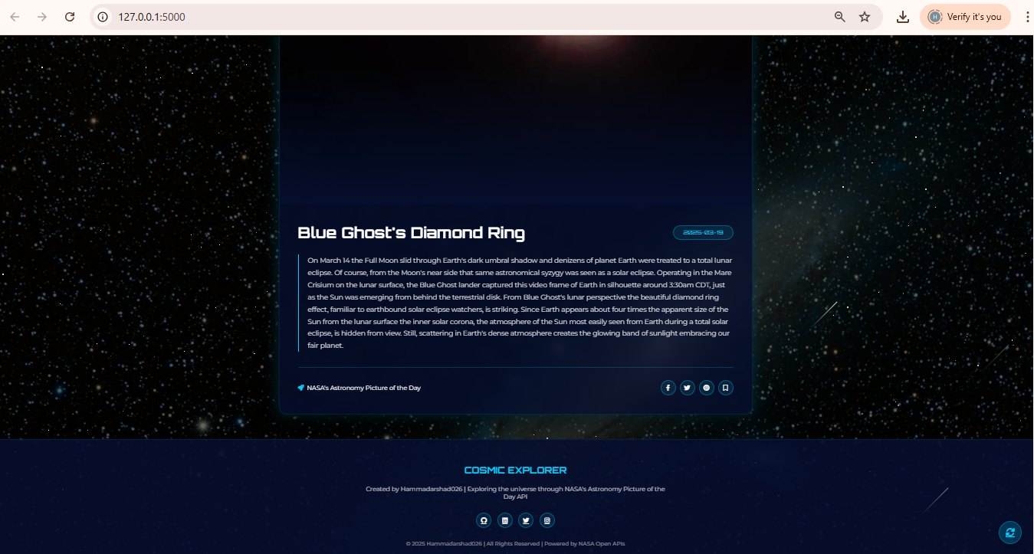

**Project Explanation: NASA Astronomy Picture App**

**Frontend (How & Why) actually made by CHATGPT**

**How the Frontend Works:**

* **HTML Structure**: Creates a responsive layout with containers for the NASA image/video and information display
* **CSS Styling**: Uses space-themed design with gradients, animations, and cosmic effects
* **JavaScript**: Adds interactive elements like loading animations, star generation, and dynamic content display
* **Responsive Design**: Adapts to different screen sizes with media queries

**Why These Frontend Choices:**

* **Immersive UI**: Space-themed design enhances user engagement with astronomical content
* **Visual Hierarchy**: Important content (images, titles) receives visual emphasis to highlight NASA's daily feature
* **Interactive Elements**: Animations provide visual feedback and create a more dynamic user experience
* **Accessibility**: Clear typography and contrasting colors make content readable for all users

**Brief Backend Mention:**

**How the Backend Works:**

* Flask app makes a simple HTTP request to NASA's APOD API
* API returns JSON data containing the image URL, title, explanation, and metadata
* Flask passes this data to the HTML template for display

**Why This Backend Approach:**

* Minimal code needed (just a few lines) to retrieve NASA's content
* API key authentication ensures secure access to NASA resources